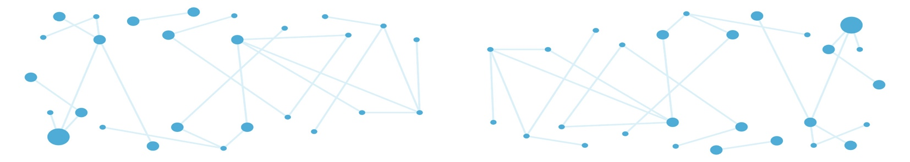

**Call for interdisciplinary research chairs**

**Group leader position in Biological Data Science**

The Dynamics of Biomolecular Networks (DYNABIO) cluster of excellence at the Université Côte d’Azur (Nice, France) brings together 82 research teams from six local biology institutes: [C3M](https://www.c3m-nice.fr/) (Centre Méditerranéen de Médecine Moléculaire); [iBV](http://ibv.unice.fr/) (Institut de Biologie Valrose); [IPMC](https://www.ipmc.cnrs.fr/fr/) (Institut de Pharmacologie Moléculaire et Cellulaire) ; [IRCAN](https://www.ircan.org/) (Institute for Research on Cancer and Aging, Nice); [ISA](https://institut-sophia-agrobiotech.paca.hub.inrae.fr/) (Institut Sophia Agrobiotech) and [LP2M](https://lp2m.univ-cotedazur.fr/) (Laboratoire de PhysioMédecine Moléculaire) as well as the Inria research institute for computer science and applied mathematics.

DYNABIO is dedicated to advancing cutting-edge research in systems and computational biology, with a central focus on the architecture, dynamics, and interactions of biomolecular networks. The interdisciplinary approach of DYNABIO bridges biology with computer science, mathematics, chemistry, and physics. Research carried out within DYNABIO teams spans a wide range of models and addresses fundamental questions in biological mechanisms, pharmacology, cell and developmental biology, and agrosciences to understand the roles & regulatory principles of biological networks in the development and function of organs and organisms as well as in human disease etiologies (cancer, inflammation, cardiometabolic disease, aging, immune and neurological disorders) and plant-microorganism interactions.

DYNABIO is launching an international call for Interdisciplinary Research Chairs to further enrich its community of researchers working at the interface of different disciplines.

**Join DYNABIO as a Group Leader in Biological Data Science**

This is a unique opportunity for an outstanding scientist to establish an independent research program at the interface of biology and computer sciences, in one of the five major DYNABIO-affiliated institutes (C3M, iBV, IPMC, IRCAN, ISA). His/her group will leverage large-scale, high-dimensional datasets—such as genomics, transcriptomics, proteomics, imaging, or single-cell data—to uncover fundamental biological mechanisms. We are particularly interested in candidates who combine computational biology, data science, and machine learning/AI with deep biological insight. While wet lab activities are welcome, they are not mandatory. However, the candidate must have demonstrated his/her ability to collaborate with biologists and have a strong publication record reflecting this interdisciplinary engagement.

S/he will also benefit from the rich Dynabio environment, including possibilities to closely interact with the local [3IA cluster of excellence](https://3ia.univ-cotedazur.eu/) on Artificial Intelligence, as well as local research centers specialized in machine learning and AI, stochastic modeling and programing or applied mathematics ([Laboratoire J.-A. Dieudonné](https://math.univ-cotedazur.fr/)) and in Computer Science ([I3S](https://www.i3s.unice.fr/en/) & [Inria](https://www.inria.fr/en/inria-centre-universite-cote-azur)), with expertise in complex data representation and processing.

**Starting package and Support**

The selected Chair holder will receive a highly competitive start-up package of €500,000 covering operating costs and salaries. The host institute will provide office and lab space, basic laboratory equipment, and full access to state-of-the-art core facilities. Furthermore, DYNABIO is committed to supporting the Chair holder in securing long-term academic positions. In return, the Chair holder is expected to contribute to the university community through either teaching or engagement in local interdisciplinary networking activities (35 hours/year).

**Eligibility**

The call is open to candidates of all nationalities, including those already holding permanent positions in France. However, applicants must not be affiliated with any DYNABIO member institute at the time of application. The interdisciplinary scope and scientific impact of the proposed research project will be key evaluation criteria.

**Application Procedure**

Applications must be submitted by [Deadline Date] to the DYNABIO direction ([florence.besse@univ-cotedazur.fr](mailto:florence.besse@univ-cotedazur.fr) and [jean-francois.tanti@univ-cotedazur.fr](mailto:jean-francois.tanti@univ-cotedazur.fr)) as well as to up to 2 candidate host institutes (see contact list below). The reference of the chair (Biological Data Science) and the name of the targeted Institutes should appear on the main front page.

C3M: sophie.tartare-deckert@univ-cotedazur.fr

iBV: ibv.direction@univ-cotedazur.fr

IPMC : lesage@ipmc.cnrs.fr

IRCAN : Dmitry.BULAVIN@univ-cotedazur.fr

ISA : philippe.castagnone@inrae.fr

Applicants should submit their application as a single PDF file organized as follows:

* Applicant’s full name, contact information (email, phone), project title, and the targeted host institute(s)
* Cover letter (1 page)
* Summary of past research activities (2 pages)
* Project description (4 pages): objectives, rationale, methodology, novelty, feasibility, and added value to the DYNABIO network and host institute
* Curriculum vitae and full list of publications (2 pages)

Shortlisted candidates will be first interviewed online by host institutes and then invited onsite for subsequent interview by the DYNABIO selection committee.