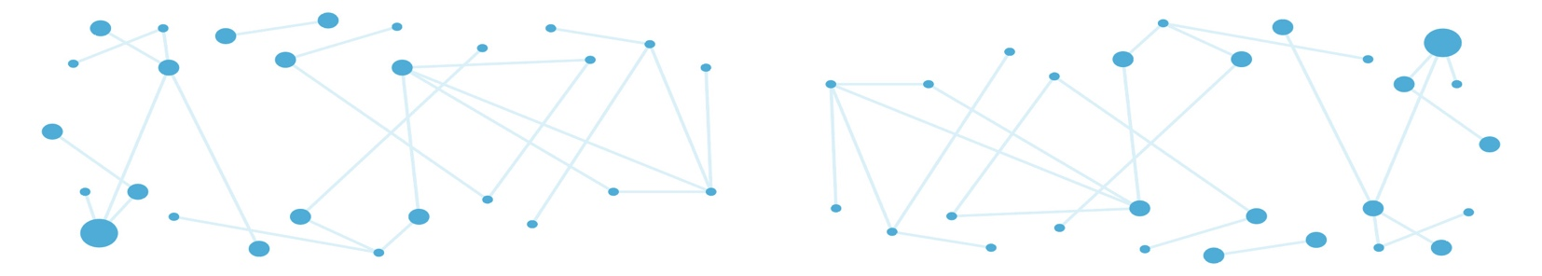

**Call for interdisciplinary research chairs**

**Group leader position in Biological Network modeling**

The Dynamics of Biomolecular Networks (DYNABIO) cluster of excellence at the Université Côte d’Azur (Nice, France) brings together 85 research teams from six local biology institutes: [C3M](https://www.c3m-nice.fr/) (Centre Méditerranéen de Médecine Moléculaire); [iBV](http://ibv.unice.fr/) (Institut de Biologie Valrose); [IPMC](https://www.ipmc.cnrs.fr/fr/) (Institut de Pharmacologie Moléculaire et Cellulaire) ; [IRCAN](https://www.ircan.org/) (Institute for Research on Cancer and Aging, Nice); [ISA](https://institut-sophia-agrobiotech.paca.hub.inrae.fr/) (Institut Sophia Agrobiotech) and [LP2M](https://lp2m.univ-cotedazur.fr/) (Laboratoire de PhysioMédecine Moléculaire) as well as the Inria research institute for computer science and applied mathematics.

DYNABIO is dedicated to advancing cutting-edge research in systems and computational biology, with a central focus on the architecture, dynamics, and interactions of biomolecular networks. The interdisciplinary approach of DYNABIO bridges biology with computer science, mathematics, chemistry, and physics. Research carried out within DYNABIO teams spans a wide range of biological models and addresses fundamental questions in biological mechanisms, pharmacology, cell and developmental biology, and agrosciences to understand the roles & regulatory principles of biological networks in the development and function of organs and organisms as well as in human disease etiologies (cancer, inflammation, cardiometabolic disease, aging, immune and neurological disorders) and plant-microorganism interactions. DYNABIO is launching an international call for Interdisciplinary Research Chairs to further enrich its community of researchers working at the interface of different disciplines.

**Join DYNABIO as a Group Leader in Biological Network modeling**

This is a unique opportunity for an outstanding scientist to develop an innovative research program at the interface of biology, applied mathematics and/or physics, within one of the five DYNABIO-affiliated institutes (C3M, iBV, IPMC, IRCAN, ISA). Applicants should have a strong background in applied mathematics or theoretical physics, with expertise in areas such as:

* Nonlinear dynamics
* Dynamical systems theory
* Stochastic processes
* ODE/PDE modeling
* Control theory

This theoretical expertise must be paired with a demonstrated interest and track record in biological applications, particularly in areas such as gene regulatory networks, cell signaling, or intercellular communication. While wet-lab components are welcome, they are not required. However, the candidate must have a proven ability to engage in effective interdisciplinary collaboration with both experimentalists and theoreticians, and a strong publication record reflecting this engagement.

The candidate will benefit from the dynamic, interdisciplinary ecosystem of the Université Côte d’Azur with opportunities to collaborate with leading international research centers: [J.A Dieudonné Laboratory](https://math.univ-cotedazur.fr/) in mathematics, applied mathematics and mathematical modeling; [I3S](https://www.i3s.unice.fr/en/) in network modeling, digital biology and health technologies; [Inria](https://www.inria.fr/en/inria-centre-universite-cote-azur) in computer science, applied mathematics and control theory, as well as [Inphyni](https://inphyni.univ-cotedazur.eu/) in theoretical and applied physics.

**Starting package and Support**

The selected Chair holder will receive a highly competitive start-up package of €500,000 covering operating costs and salaries. The host institute will provide office and lab space, basic laboratory equipment, and full access to state-of-the-art core facilities. Furthermore, DYNABIO is committed to supporting the Chair holder in securing long-term academic positions. In return, the Chair holder is expected to contribute to the university community through either teaching or engagement in local interdisciplinary networking activities (35 hours/year).

**Eligibility**

The call is open to candidates of all nationalities, including those already holding permanent positions in France. However, applicants must not be affiliated with any DYNABIO member institute at the time of application. The interdisciplinary scope and scientific impact of the proposed research project will be key evaluation criteria.

**Application Procedure**

Applications must be submitted by [Deadline Date] to the DYNABIO direction ([florence.besse@univ-cotedazur.fr](mailto:florence.besse@univ-cotedazur.fr) and [jean-francois.tanti@univ-cotedazur.fr](mailto:jean-francois.tanti@univ-cotedazur.fr)) as well as up to 2 candidate host institutes (see contact list below). The reference of the chair (Biological Network Modeling) and the name of the targeted Institutes should appear on the main front page.

C3M: sophie.tartare-deckert@univ-cotedazur.fr

iBV: ibv.direction@univ-cotedazur.fr

IPMC : lesage@ipmc.cnrs.fr

IRCAN : Dmitry.BULAVIN@univ-cotedazur.fr

ISA : philippe.castagnone@inrae.fr

Applicants should submit their application as a single PDF file organized as follows:

* Applicant’s full name, contact information (email, phone), project title, and the targeted host institute(s)
* Cover letter (1 page)
* Summary of past research activities (2 pages)
* Project description (4 pages): objectives, rationale, methodology, novelty, feasibility, and added value to the DYNABIO network and host institute
* Curriculum vitae and full list of publications (2 pages)

Shortlisted candidates will be first interviewed online by host institutes and then invited onsite for subsequent interview by the DYNABIO selection committee.