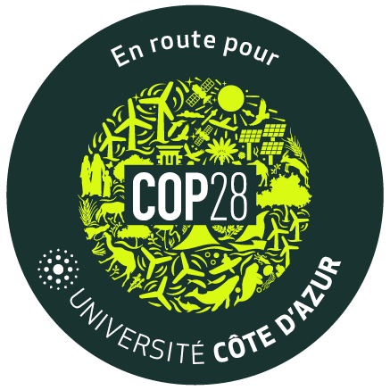

Call for Contribution Climate Change
Academic Advocacy Collection UCA^{JEDI}

Sustainability and Climate Change: cause, consequences, impact, adaptation, mitigation and solution

Date limit: October 31th for the full article
contact: advocacy@univ-cotedazur.fr

Given name of the Contributor(s)
Last name of the Contributor(s)
Title(s)
If Applicable, Research Unit and/or Component (EUR, derogatory or associated component)
Name of the Advocacy Peace
Main Topic (i.e: energy, resilience, adaptation, smart territory, education, risks, one health, etc.
Free Key Words (up to 5)
Abstract in English (500 characters space included)

Abstract in French (500 characters space included)

Advocacy Piece
- The article should be written preferably in English
- Police Size: Arial, Times Roman or Calibri 11
- Margins: the margins of the present document should not be modified
- Length: Maximum 10.000 characters space included (approx. 3 pages)
- References must be included and will not count in the 10.000-character limit
- Each contributor is free to use the tone he wants but please keep in mind the Academic Advocacy Collection is addressed primarily to policy and decision makers and secondarily to the civil society at large. Thus, we encourage the contributors to make sure their contributions can be understood among the non-academic community.
- We consider Climate Change as a global phenomenon and the contributions should not be limited to the rise in temperature. As such, topics related to risks, environmental impact on health and healthy living, acceptance and behaviour change, etc. perfectly address our expectations.

